Preexcitation syndrome in Children

울산의대 서울아산병원 소아심장과
고 재곤

- Introduction
Preexcitation is caused by an anomalous atrioventricular connection(bypass tract, accessory pathway) capable of antegrade and usually retrograde conduction. A delta wave is the main electrocardiographic abnormality, together with a short PR interval. Wolff-Parkinson-White syndrome(WPW) was initially reported in healthy young people with both preexcitation in the surface ECG and symptoms caused by tachyarrhythmias.¹ The approximate incidence of WPW is 1-4/1000. Longitudinal studies show that only about 50% of patients with preexcitation will eventually develop symptoms requiring treatment and in upto 30% of patients, the ability of the bypass tract to conduct anterogradely is lost over time.²⁻⁴ The arrhythmia with WPW is either a regular tachycardia based upon reentrant tachycardia incorporating the atrioventricular node-His pathway and accessory AV connection or atrial fibrillation. Atrial fibrillation with rapid anterograde conduction over an accessory pathway may be a catastrophic event leading to sudden death, which might be the first event in patients with previously asymptomatic WPW. In the era of radiofrequency catheter ablation of WPW, there is no doubt about management strategies of symptomatic patients. However, there are some debates on what to do in the asymptomatic WPW patients. Moreover in children with WPW, assessing the risk of sudden death is difficult because these catastrophic events are infrequently observed in children with WPW and risk factors for sudden death, developed in adult studies, are not clearly applicable to children.

- Electrocardiographic Diagnosis
The typical patterns of ventricular preexcitation are short PR interval, wide QRS, and slurring of the upstroke of the QRS complex(delta wave).(Fig. 1) Secondary changes in the T waves are also frequently seen. This ECG feature is the result of fusion between impulse conducting over the accessory pathway and impulse conducting via the normal AV node-His pathway. Preexcitaion ECG is frequently misdiagnosed as bundle branch block, myocardial infarction and ventricular hypertrophy.
The time interval in the ECG depends on the age of patients and following criteria may be used for definition of preexcitation in children.⁵
PR interval QRS duration
< 2 years < 0.08 sec > 0.08 sec
2-10 years < 0.10 sec > 0.10 sec
> 10 years < 0.12 sec > 0.12 sec

Fig. 1. ECG of WPW syndrome
The WPW ECG, seen in the diagram, shows a short PR, delta wave, and somewhat widened QRS.
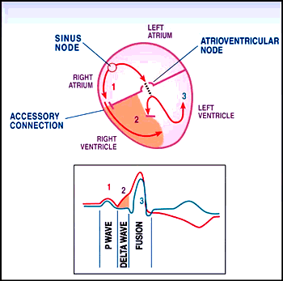
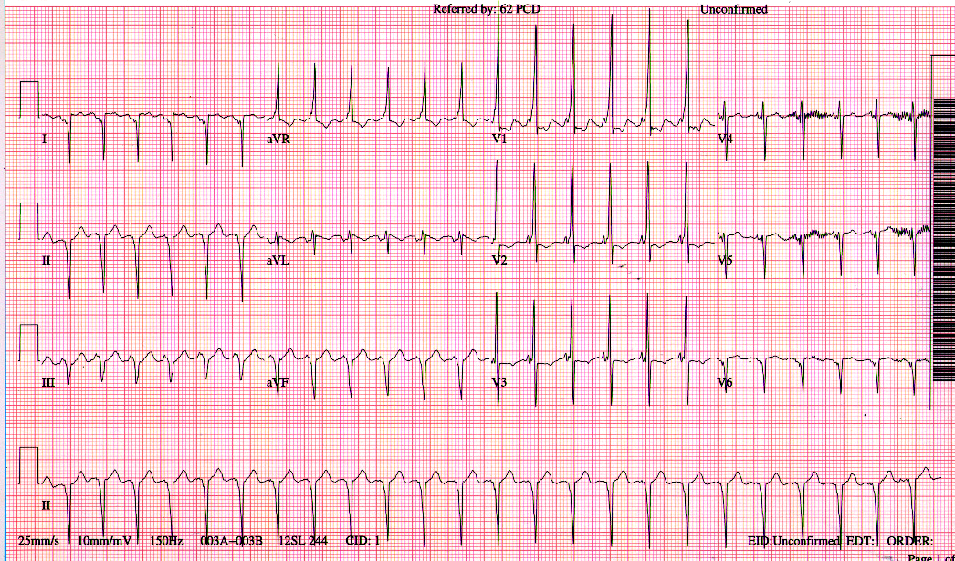
3. Associated Cardiac Anomalies
WPW is accompanied by congenital heart defects in about 20-30% of cases. The most common malformations are Ebstein’s anomaly, congenitally corrected transposition, cardiomyopathy, tricuspid atresia and ventricular septal defect.⁵ The patients with congenital heart defects and WPW may be at a higher risk to develop symptoms.⁶ These patients frequently have dilated cardiac chambers which provide for atrial or ventricular extrasystole and initiate reentrant tachycardia. In these patients, tachycardia may produce a low cardiac output state or significant cyanosis from a right to left shunt and may result in more severe symptoms at a low heart rate due to abnormal hemodynamics.

- Arrhythmias in WPW syndrome
The patients with WPW are prone to develop paroxysmal tachycardias including AV reentrant tachycardia and atrial fibrillation. But it is not known exactly what fraction of patients with preexcitation will eventually develop tachyarrhythmias and why the majority of patients don’t become symptomatic until adulthood.
- Atrioventricular reentrant tachycardia
The most frequent arrhythmia with WPW is reentrant tachycardia incorporating the AV node-His pathway and accessory AV connection. The peak age for occurrence of tachycardia in childhood is the first 2 months of age, with almost 40% of first episodes of tachycardia taking place in this period. The frequency of tachycardia decreases markedly through infancy, with at least 2/3 of infants no longer having tachycardia at 1 year of age. Occurrences and recurrences of tachycardia appear again in the 5-8 and 10-13 year old age group.⁵⁻⁷ Those AV reentrant tachycardia with antegrade conduction over the AV node and retrograde conduction via accessory pathway(orthodromic tachycardia) have narrow QRS morphology. Retrograde conduction through the accessory pathway is usually rapid, resulting in a short RP´ interval. Therefore the ECG of orthodromic tachycardia is characterized by a narrow QRS complex with the P wave inscribed shortly after QRS complex.(Fig. 2) However, wide QRS morphology may be seen in the case of aberration of QRS complex due to functional bundle branch block. Contrary to orthodromic tachycardia, in about 10% of patients with WPW, the AV reentrant tachycardia utilises the bypass tract for antegrade conduction and AV node or another bypass tract for retrograde conduction(antidromic tachycardia), producing maximally preexcited wide QRS morphology.(Fig. 3) This tachycardia, therefore, may easily be interpreted as ventricular tachycardia. In a regular tachycardia with wide QRS complex, antidromic reentrant tachycardia, orthodromic tachycardia or atrial tachycardia with bundle branch block, fixed or functional, atrial tachycardia with 1:1 antegrade conduction through accessory pathway and ventricular tachycardia should be thought as mechanism of tachycardia.⁵

- Atrial fibrillation and atrial flutter
Atrial fibrillation and atrial flutter has been reported to occur spontaneously in 11 to 39% of adult WPW patients. In WPW syndrome, atrial fibrillation may be life-threatening by rapid anomalous conduction to ventricle through accessory pathway with a short refractory period, predisposing to cardiovascular collapse.^{8,9} The occurrence of atrial fibrillation in patient with WPW ＜12 years old has only been rarely. Atrial fibrillation is extremely rare in infancy and atrial flutter is present in 1-4% of infants with preexcitation. However, this phenomenon should be kept in mind when managing children with WPW.^{5,10,11}

Fig. 2. Orthodromic reentrant tachycardia
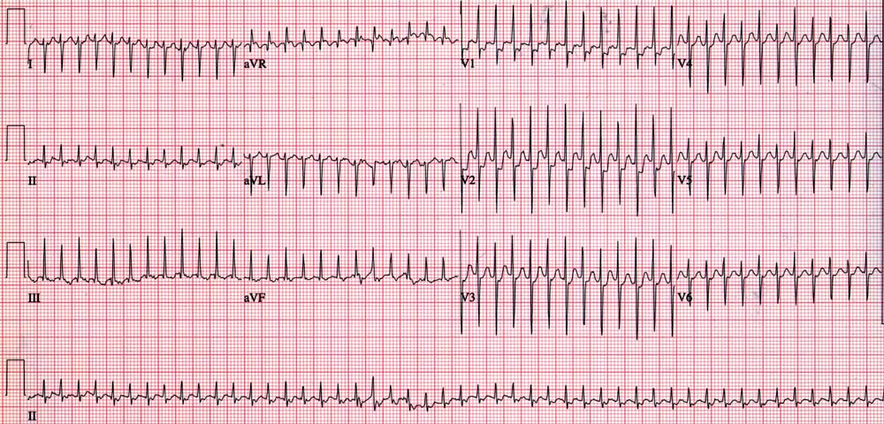

Fig. 3. Antidromic reentrant tachycardia
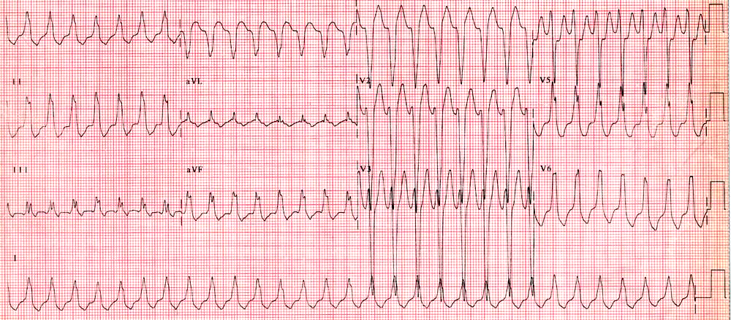

- The asymptomatic WPW patients
The management of mildly symptomatic and asymptomatic patients remains controversial with the relatively small risk of sudden arrhythmic death. Incidence of these event in asymptomatic individuals has been estimated to be at 1 per 1,000 patient/year. The lifetime incidence of sudden death in a symptomatic child with WPW has been estimated as 3-4%.¹² However, almost half of children suffering cardiac arrest with WPW had no prior important clinical events.¹³
The sudden death usually occurs as the result of atrial fibrillation with an extremely rapid ventricular response due to conduction over the accessory pathway predisposing to electrical instability and hemodymic impairment. The preexcited R-R interval ,during atrial fibrillation, of less than 220 msec has generally been used to identify the patients at high risk.^{8,9,10} In children, as well as in adults, the incidence of atrial fibrillation is higher in the presence of WPW compared to those without WPW. However, the spontaneous occurrence of atrial fibrillation is much less common in children because of electrical stability of the smaller healthy atrial chambers. The other characteristic of the patients with WPW at high risk have included: an effective refractory period of less than 270 msec for antegrade conduction, the presence of septal bypass tracts, and presence of multiple pathways. In adults with WPW, there is a well-established relationship between the presence of symptoms and the risk of sudden death.^{8,9} However, an invasive study undertook in children with WPW showed no differences between the symptomatic patients and asymptomatic patients for these risk factors and this study suggested that risk factors for sudden death, developed in adult stuides, are not clearly applicable to children.¹²
In the asymptomatic patients with WPW pattern as an incidental finding on an ECG, assessment of sudden death risk is important but most controversial. Intermittent preexcitation and loss of preexcitation during exercise indicate a long refractory period of the antegrade accessory pathway. Pharmacological tests can also help identify those patients with relatively long refractory periods, intravenous administration of antiarrhythmic drugs such as procainamide and ajmaline results in loss of accessory conduction. However, these noninvasive methods are useful in identifying patients at low risk, but their major limitations are the low specificity and predictive accuracy for patients at high risk.^{9,13}
Electrophysiologic studies and radiofrequency ablation have become quite safe in children but futher studies are needed better to define the indications for study and ablation in asymptomatic children with WPW.

References

1. Wolff L, Parkinson J, White PD. Bundle-branch block with short PR interval in healthy young people prone to paeoxysmal tachycardia. Am Heart J 1930;5:685-704.
2. Munger TM, Packer DL, Hammill SC, et al. A population study of the natural history of Wolff-Parkinson-White syndrome in Olmsted county, Minnesota, 1953-1989. Circulation 1993;87:866-73.
3. Klein GJ, Yee R, Sharma AD. Longitudinal elctrophysiological
assessment of asymptomatic patients with the Wolff-Parkinson-White
syndrome electrocardiographic pattern.
N Eng J Med 1989; 320:1229-33.
4. Goudevenos JA, Katsouras CS, Graekas G, Argiri O, Giogiakas V,
Sideris DA. Ventricular preexcitation in the general population: a
study on the mode of presentation and clinical course.
Heart 2000;83:29-34.
5. Losekoot TG, Lubbers WLJ. The Wolff-Parkinson-White syndrome in childhood. Intern J Cardiol 1990;27:293-309.
6. Deal BJ, Keane JF: Wolff-Parkinson-White syndrome and
supraventricular tachycardia during infancy: management and follow-
up, J Am coll Cardiol 1985; 5:130-5.
7. Perry JC, Garson A. Supraventricular tachycardia due to Wollf
-Parkinson-White syndrome in children: early disappearance and late recurrence. J Am Coll Cardiol 1990; 16:1215-20.
8. Zardini M, Yee R, Thakur RK, Klein GJ. Risk of sudden arrhythmic
death in the Wolff-Parkinson-White syndrome:current perspectives.
Pacing Clin Electrophysiol 1994;17:966-75.
9. Wellens HJ, Rodriguez LM, Timmermans C, Smeets J. The
asymptomatic patients with the Wolff-Parkinson-White
electrocardiogram.
Pacing Clin Electrophysiol 1997;20(Pt .II):2082-6.
10. Bromberg BI, Lindsay BD, Cain ME, Cox JL. Impact of clinical history and electrophysiologic characterization of accessory pathways on management strategies to reduce sudden death among children with Wolff-Parkinson-White Syndrome. J Am Coll Cardiol 1996;27:690-5.
11. Vignati G, Balla E, Mauri L, Lunati M, Figini A. Clinical and
electrophysiologic evolution of the Wolff-Parkinson-White syndrome
in children:impact on approaches to management.
Cardiol Young 2000;10:367-75.
12. Deal BJ, Dick M, Beerman L, Silka MJ. Cardiac arrest in young
patients with Wolff-Parkinson-White syndrome.
Pacing Clin Electrophysiol 1995;18(Part II):815(abstract).
13. Dubin AM, Collins KK, Chiesa N, Hanisch D, Van Hare GF. Use of
electrophysiologic testing to assess risk in children with Wolff-
Parkinson-White syndrome. Cardiol Young 2002;12:248-52.

